rootes group car club qld inc – sunbeam members

SUNBEAM OWNERS of QUEENSLAND
Present the

46th Sunbeam Nationals

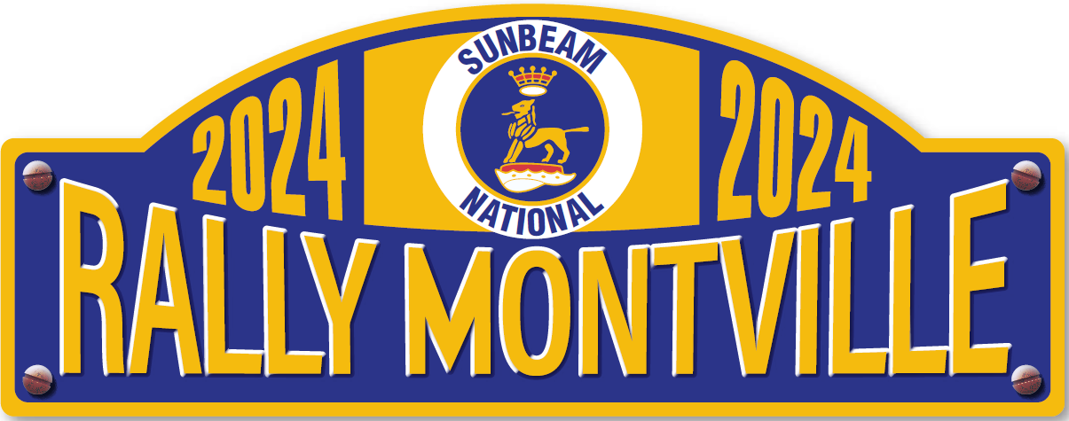

6th – 9th September 2024

We invite you to join us in beautiful
Montville
A picturesque market town in the Sunshine Coast Hinterland
And a boutique shopping haven for tourists and locals
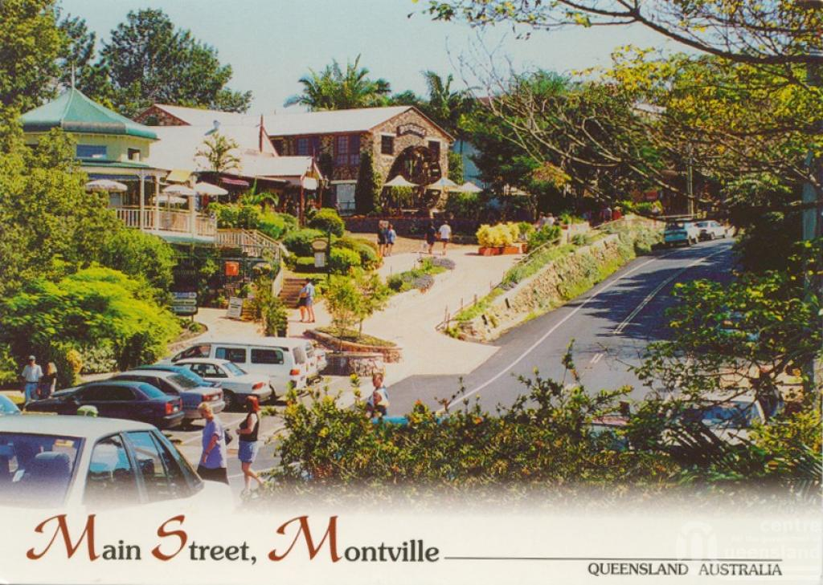
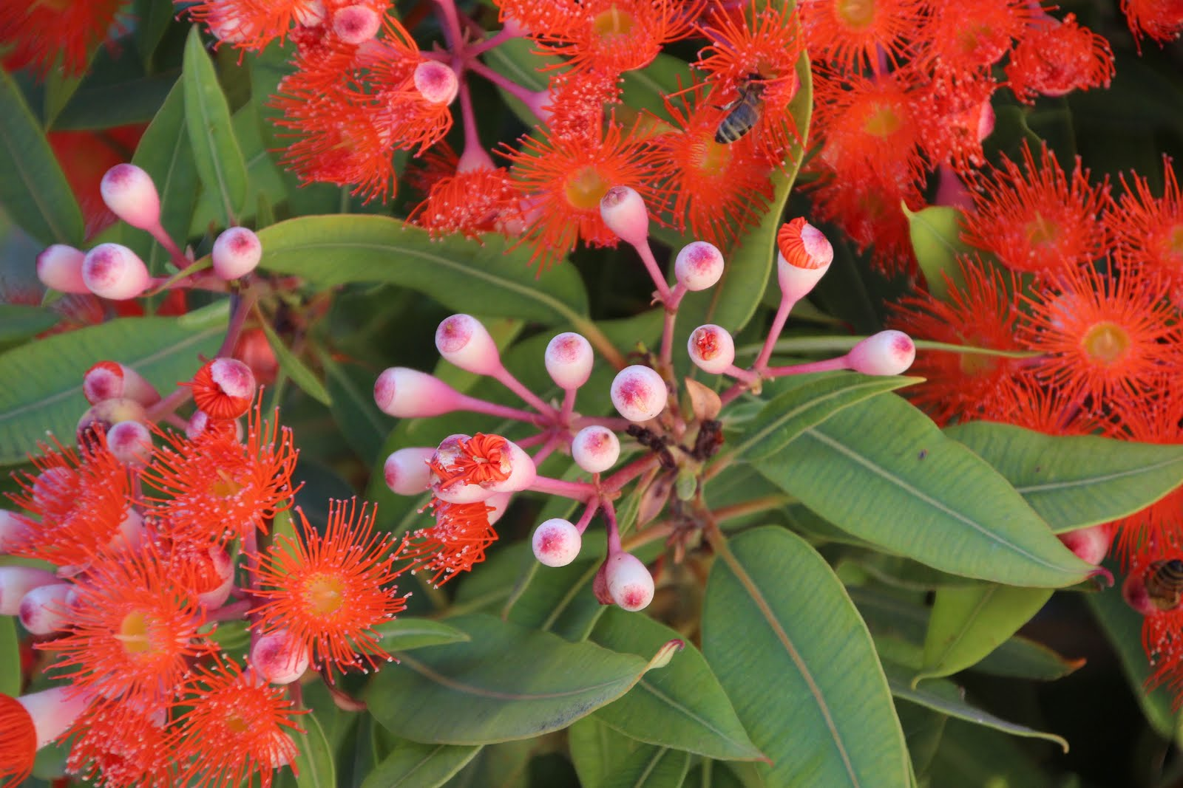

SPRING 2024

WHERE IS MONTVILLE?
- The town is situated near the beautiful Glasshouse Mountains in the Sunshine Coast Hinterland

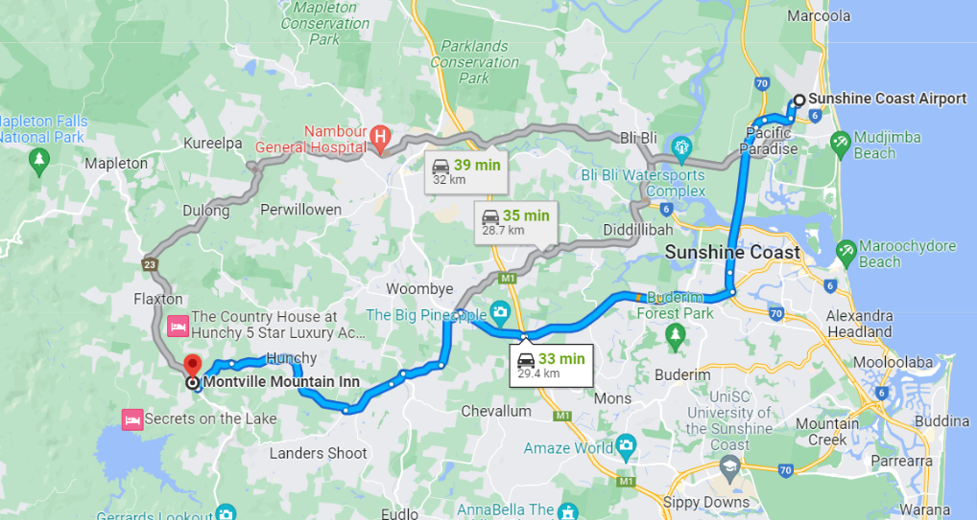
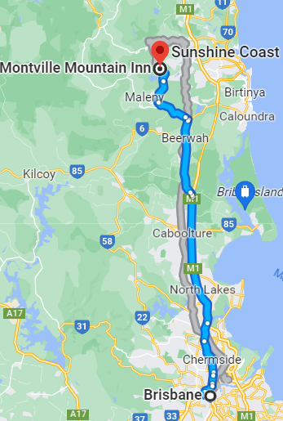

For those who wish to fly in, there are direct flights to Maroochydore or Brisbane

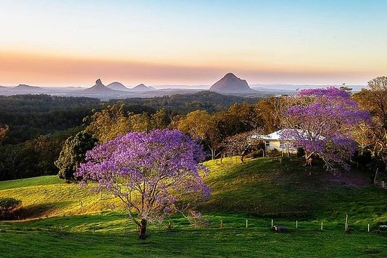

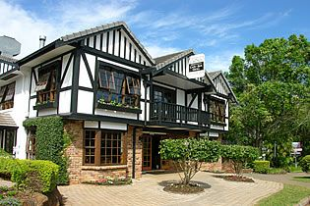

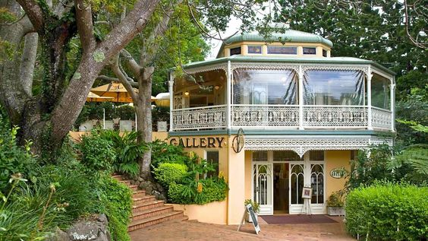

ACCOMMODATION ARRANGEMENTS

2024 Sunbeam National Meet

Nights of Friday 6th September, Saturday 7th & Sunday 8th September 2024

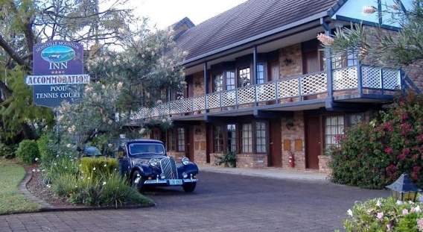
Montville Mountain Inn Resort

118 Main Street Montville Qld 4560
Reception 8.00am – 5.00pm 7 days
Phone: 07 5442 9499 Fax: 07 5442 9303
Email: reception@montvilleinn.com.au
Web: www.montvilleinn.com.au

The Mountain Inn Resort will be the focal point for all National Meet activities

- 26 rooms available
- Car parking outside unit - off street
- Undercover parking available locally
- Car washing facilities
Breakfast provided as part of your entertainment package and served at
The Montville Café Bar & Grill next door to the Montville Inn Resort
We have block booked the accommodation under Sunbeam Nationals please refer to this when making your booking

OVERFLOW ACCOMMODATION
Mayfield on Montville
127-133 Main St, Montville QLD 4560
Phone: 07 5442 9499 (same as for Mountain Inn Resort)
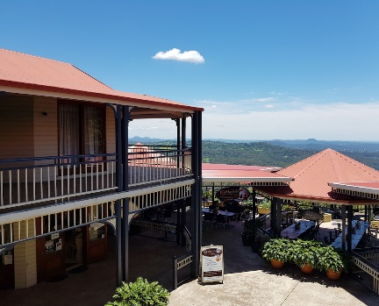
- Over the road from Mountain Inn Resort above “The Edge Restaurant”
- 10 Luxurious self-contained apartments
- Undercover parking
- Spectacular views

NON-RESERVED ACCOMMODATION

Altitude on Montville
94-96 Main St, Montville QLD 4560
Phone: (07) 5478 5889
Email: admin@altitudeonmontville.com.au
ENTERTAINMENT PACKAGE
For the weekend activities your package is priced at $285.00 per person, which offers the following inclusions:
- Friday evening - drink & appetisers followed by dinner
  - Saturday morning breakfast
- Saturday evening - dinner
  - Sunday morning - breakfast
- Sunday evening - Presentation Dinner
  - Monday morning - Breakfast
All meals will be at the Montville Café Bar & Grill which is next door to the Hotel
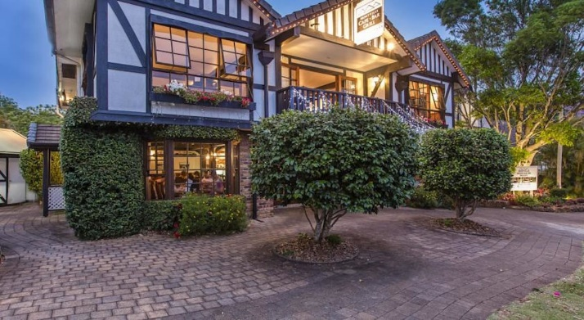

To confirm your Registration, a deposit of $60 is required by 1st March 2024 with the balance due by 1st June 2024
(Some members may wish to pay in full before 1st March)
Payment details - - - -
- Post: Bob Otto, Treasurer – Sunbeam Nationals Qld
PO Box 31
Underwood Qld 4119
- Electronic Transfer: Rootes Group
BSB: 124-012 (BOQ – Wynnum)
Account Number: 90058958

- Email: bobotto@optusnet.com.au
Cc email to robheiner@hotmail.com
Let us know that you’ve booked by emailing or Aust-posting a copy of your Registration Booking Form to the above address/es
****Include your name/s & State****
PLEASE NOTE: For anyone flying in to the Nationals we will endeavour to pick up from Maroochydore Airport if arrival times can be co-ordinated, the latest being 3pm on Friday
We will also have some car spaces available for the fun runs so that you will be able to join in.

PROVISIONAL PROGRAM
SEPTEMBER 6th – 9th
Thursday 5th
 | - The committee will be on-site from 10.00am and available for anyone who wishes to arrive a day early
Friday 6th
2pm onwards  Evening | - Arrival, check-in, registration & car washing  - Welcome and Briefing ~ including a welcome drink -beer, wine or soft drink- and appetisers  - Dinner at Montville Café Bar & Grill  (Included in Entertainment Package)
Saturday 7th
7.30 - 9am  Morning  Midday  Evening | - Breakfast (Included in Entertainment Package)  - Car display & judging (Those members not involved may wish to explore/shop in the town)  - Drive time with a stop for lunch  - Dinner at Montville Café Bar & Grill  (Included in Entertainment Package)
Sunday 8th
7.30 - 9am  9.00am  10.30am  Evening | - Breakfast (Included in Entertainment Package)  - Presidents' Meeting  - Fun Run – stopping for lunch on the fun run  - Presentation Dinner at Montville Café Bar & Grill (Included in Entertainment Package)
Monday 9th
7 - 9am  10am | - Breakfast (Included in Entertainment Package)  - Check-out, farewells & departures
We strongly advise you to extend your stay on the Sunshine Coast as there is so very much to see and do, that we have been unable to fit into the weekend. Some of these attractions will be shown on the following pages.

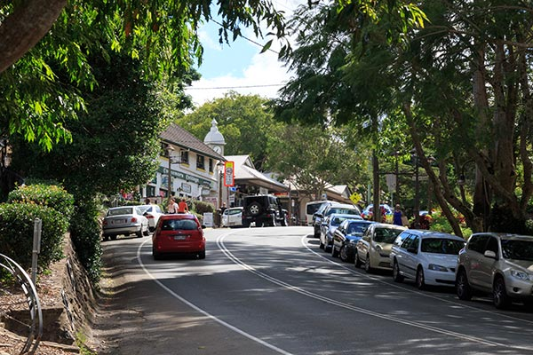
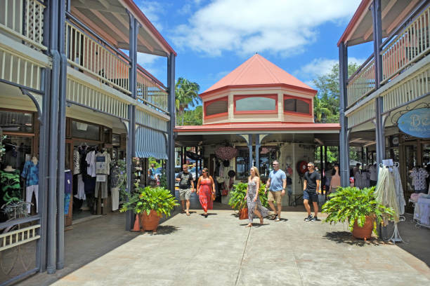
A LITTLE of MONTVILLE IN PICTURES
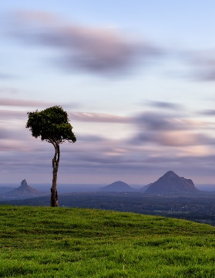
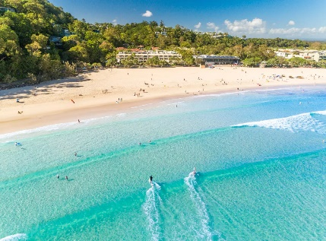
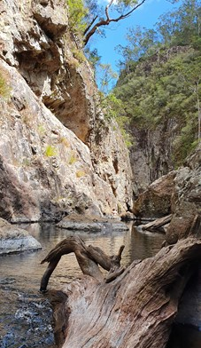
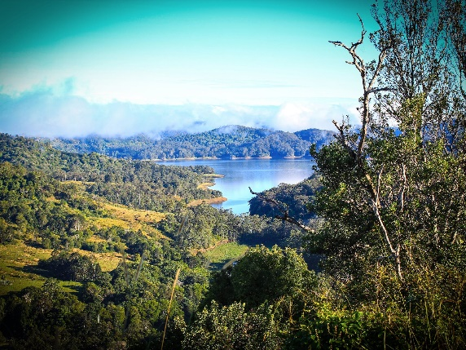
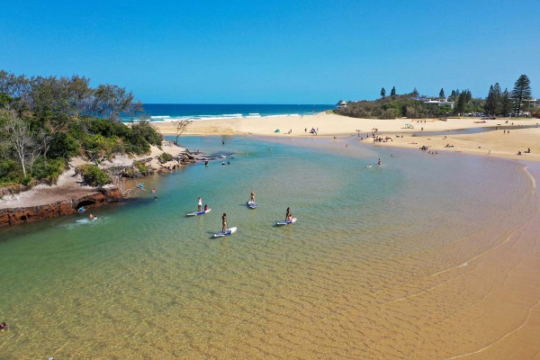
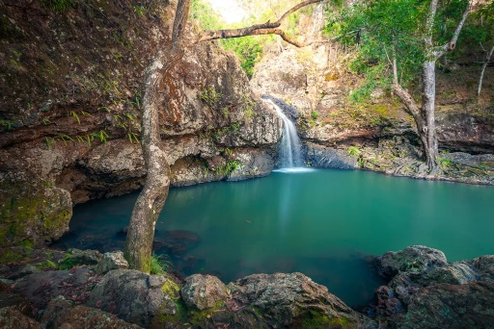
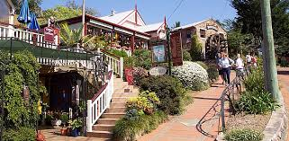
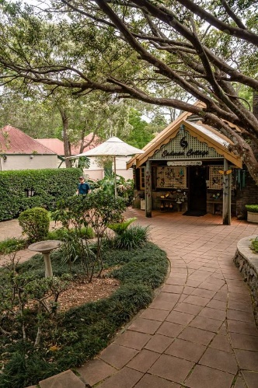
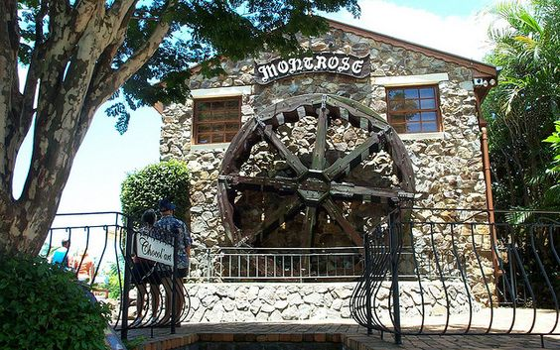
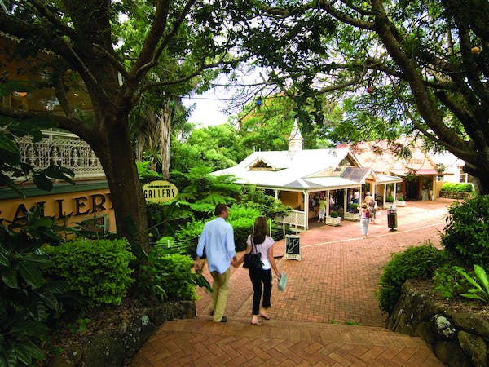
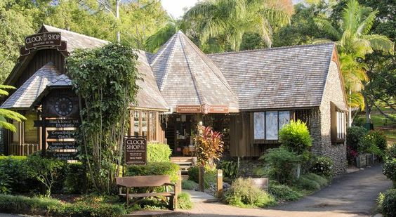
Currumundi Lake & Beach
Noosa Main Beach
Howells Knob Lookout

Obi Obi Gorge

Baroon Pocket Dam
Kondalilla Falls
AND SOME OF THE SURROUNDING DISTRICT
MORE THINGS TO SEE AND DO
These are just a sample of what the Sunshine Coast has to offer
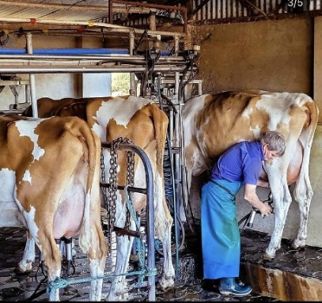
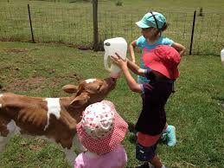
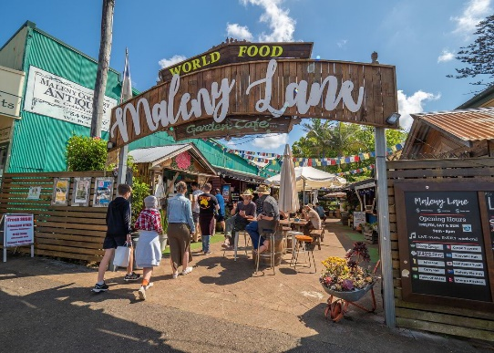

Maleny Markets
Maleny Dairy Tour
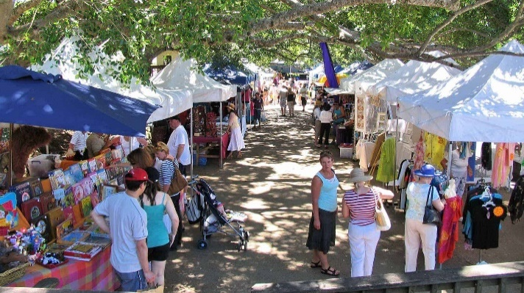
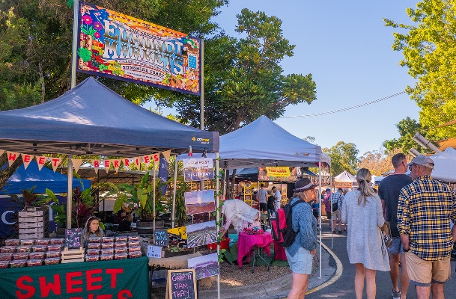

Eumundi Markets
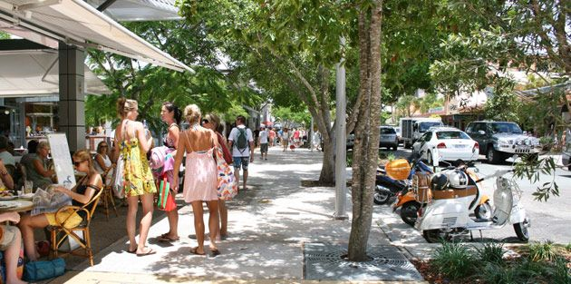
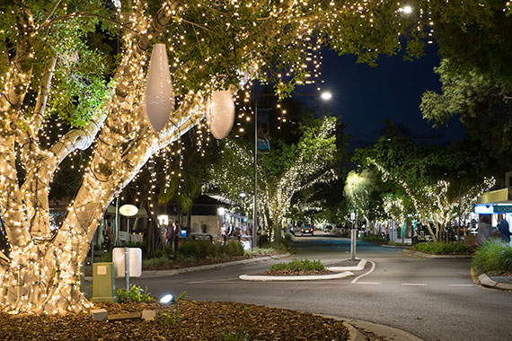

Hastings Street, Noosa
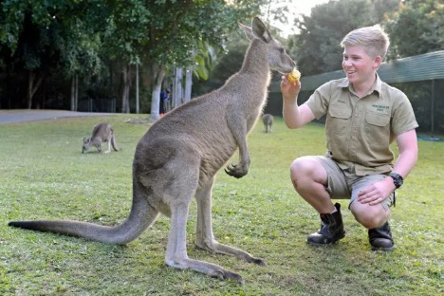
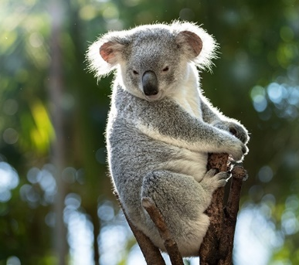

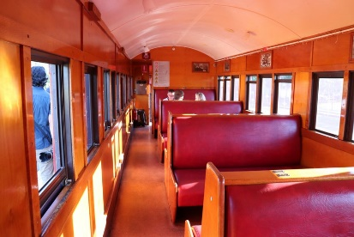
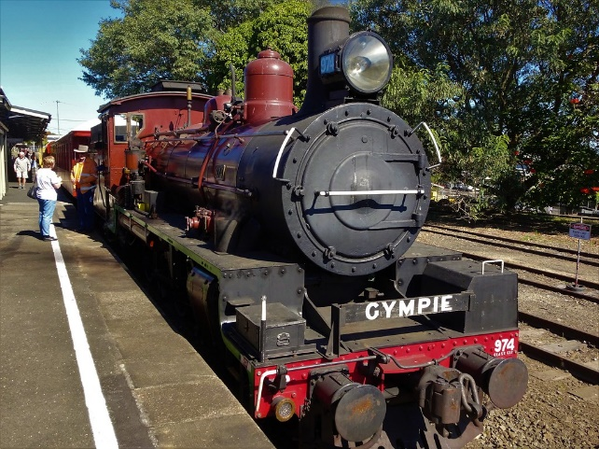
Australia Zoo
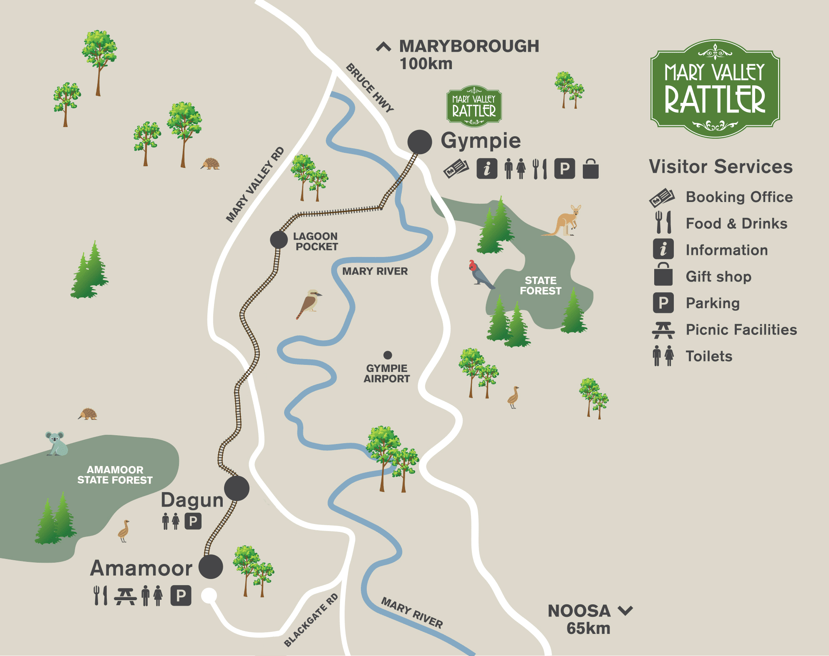
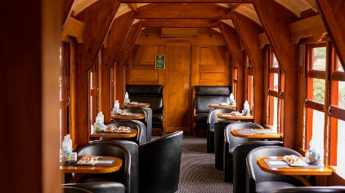
The Valley Rattler – Gympie to Amamoor return
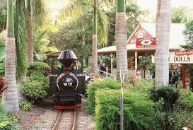
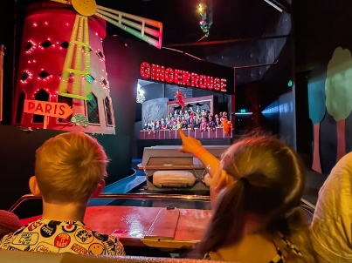
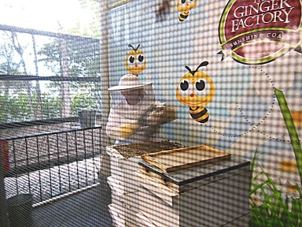
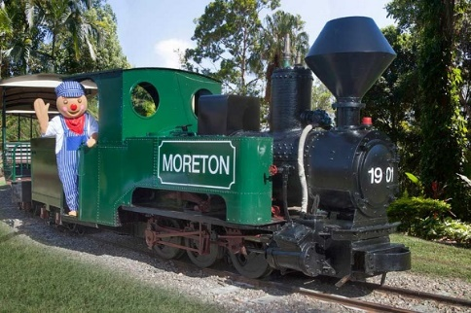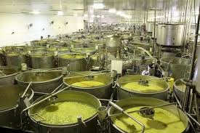

The Ginger Factory at Yandina

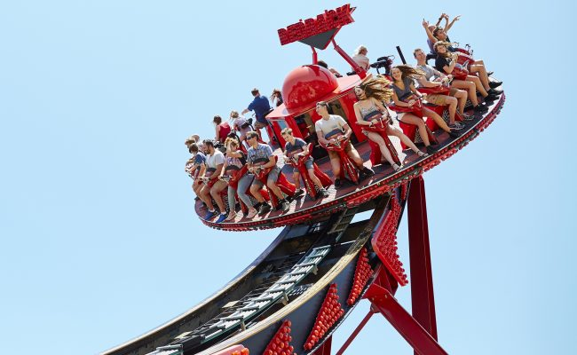
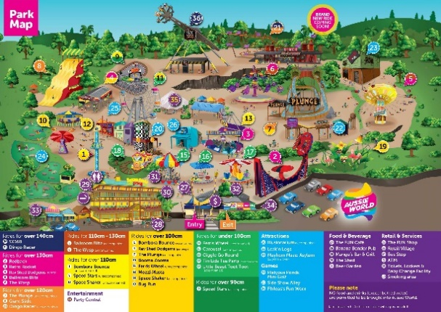

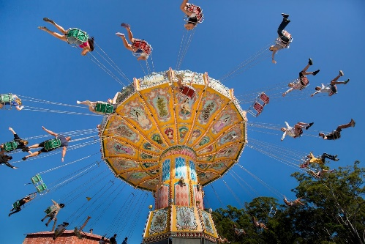
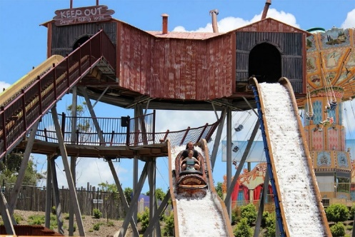

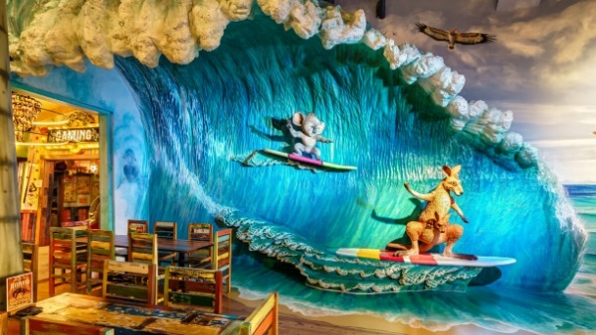
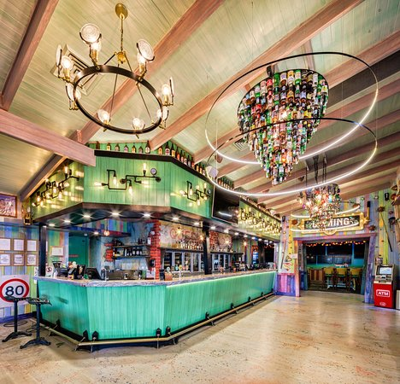
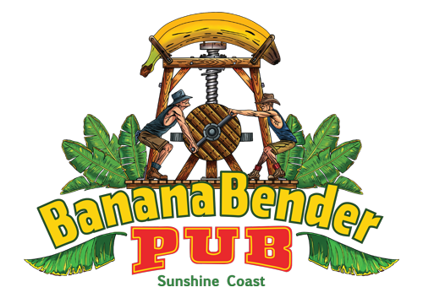

Aussie World & The Banana Bender Pub at Palmview
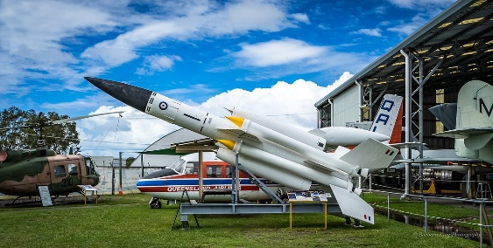
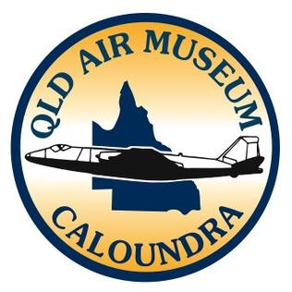
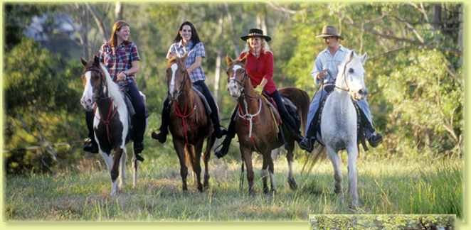
The Air Museum at Caloundra
Horseriding in Mooloolah Valley

And some views of your accommodation choices
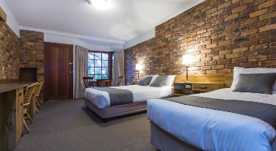
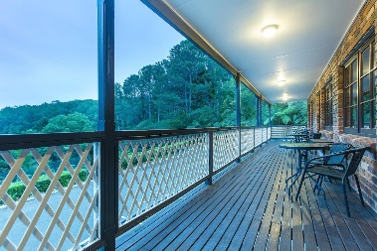
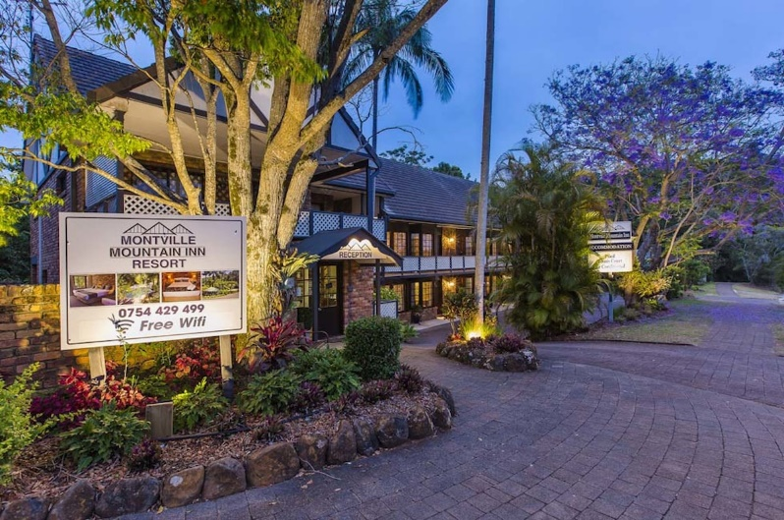

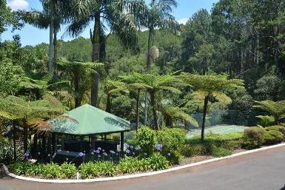
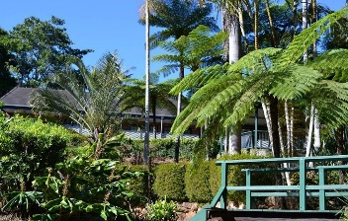

Montville Mountain Inn Resort
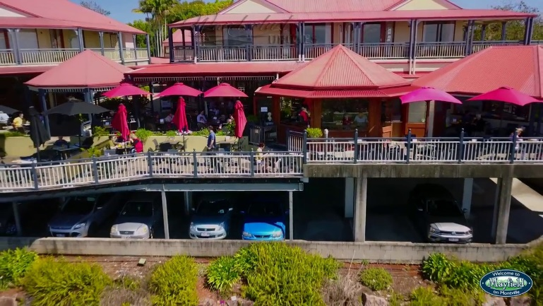
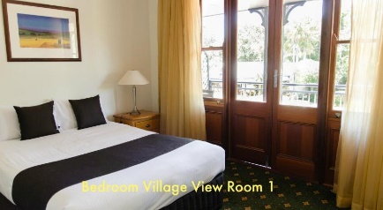
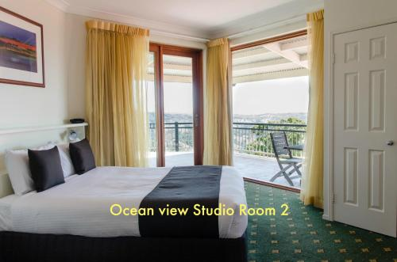

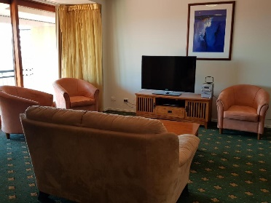
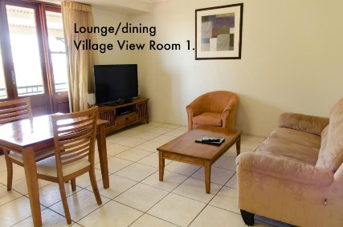

Mayfield on Montville

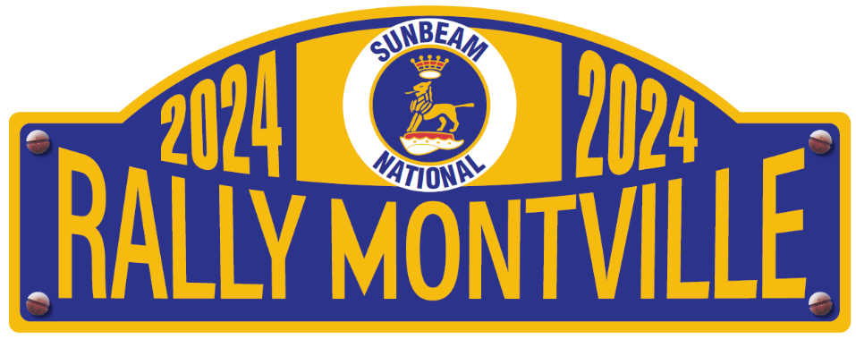

On behalf of the Sunbeam Owners of Queensland Organising Committee
Clyde Northcott
Bob Otto
Rob Heiner
Gayle Heiner
we look forward to your company at the 46th National Sunbeam Meet.
